Pcap -> csv
ML PROJECT

- Pcap -> csv
The ISOT dataset is the combination of several existing publicly available malicious and non-malicious datasets. It contains the network traffic data in the form of pcap files
First need to extract required fields from pcap to csv format. Luckily wireshark has a cmd line tool called tshark. It even has a tool called editcap. I used it to convert the 10gb pcap file into smaller 17 files. I wrote a simple python script to convert the files into csv format
The following fields extracted from pcap files:
- frame.number
- frame.time_epoch
- frame.len
- Ip.src
- Ip.dst
- Ip.proto
- Tcp.srcport
- Tcp.dstport
- Tcp.flags
- Tcp.window_size
- udp.srcport
- udp.dstport
- udp.length
- dns.qry.name
- http.host

Script:

import subprocess

pcap_folder = r"C:\Users\Skeletron\Desktop\temp"
output_folder = r"C:\Users\Skeletron\Desktop\dataset"

fields = [
"frame.number", "frame.time_epoch", "frame.len",
"ip.src", "ip.dst", "ip.proto",
"tcp.srcport", "tcp.dstport", "tcp.flags", "tcp.window_size",
"udp.srcport", "udp.dstport", "udp.length",
"dns.qry.name", "http.host"
]
fields_arg = " ".join([f"-e {field}" for field in fields])

for i in range(1, 18): # Loop from 1 to 17
pcap_file = f"{pcap_folder}\\{i}.pcap"
csv_file = f"{output_folder}\\{i}.csv"

tshark_cmd = f'tshark -r "{pcap_file}" -T fields {fields_arg} -E header=y -E separator=, -E quote=d > "{csv_file}"'
subprocess.run(tshark_cmd, shell=True, check=True)

print(f" Converted: {pcap_file} -> {csv_file}")

print("All files converted!")

- Also Adding label column using the dataset description provided
import pandas as pd
import os

# Malicious IPs from ISOT dataset
MALICIOUS_IPS = {
'172.16.2.11', '172.16.0.2', '172.16.0.11',
'172.16.0.12', '172.16.2.12'
}

# Folder containing your CSV files
INPUT_FOLDER = r"C:\Users\Skeletron\Desktop\dataset"

for filename in os.listdir(INPUT_FOLDER):
if filename.endswith('.csv'):
file_path = os.path.join(INPUT_FOLDER, filename)

df = pd.read_csv(file_path)

if 'is_malicious' not in df.columns:
df['is_malicious'] = (
df['ip.src'].isin(MALICIOUS_IPS) |
df['ip.dst'].isin(MALICIOUS_IPS)
).astype(int)

# Overwrite original file
df.to_csv(file_path, index=False)
print(f" Added labels to {filename}")

Data Cleaning
- Data Cleaning

Making sure all the fields have the correct data types before working on them

Converting to appropriate datatypes

Field | Before | After
frame.number | Int64 | Int64
frame.time_epoch | float64 | datatime
frame.len | Int64 | Int64
ip.src | object | category
ip.dst | object | category
ip.proto | object | Int64
tcp.srcport | float64 | Int64
tcp.dstport | float64 | Int64
tcp.flags | object | Int64
tcp.window_size | float64 | Int64
udp.srcport | float64 | Int64
udp.dstport | float64 | Int64
udp.length | float64 | Int64
dns.qry.name | object | Int64
http.host | object | Int64

Converting frame.time_epoch to datetime
df['frame.time_epoch'] = pd.to_datetime(df['frame.time_epoch'], unit='s', errors='coerce')
Handling multiple ips and converting to category type
df['ip.src'] = df['ip.src'].str.split(',').str[0]
df['ip.dst'] = df['ip.dst'].str.split(',').str[0]
df['ip.src'] = df['ip.src'].astype('category').cat.add_categories('<empty>').fillna('<empty>')
df['ip.dst'] = df['ip.dst'].astype('category').cat.add_categories('<empty>').fillna('<empty>')

Converting tcp.flag to int
def is_hex(value):
try:
int(value, 16)
return True
except (ValueError, TypeError):
return False

df['tcp.flags'] = df['tcp.flags'].apply(lambda x: int(x, 16) if pd.notna(x) and is_hex(x) else pd.NA).astype('Int64')

Converting rest of the numeric cols to int
numeric_cols = [
'frame.number', 'frame.len', 'ip.proto', 'tcp.srcport',
'tcp.dstport', 'tcp.flags', 'tcp.window_size',
'udp.srcport', 'udp.dstport', 'udp.length'
]
df[numeric_cols] = df[numeric_cols].apply(pd.to_numeric, errors='coerce').astype('Int64')

Data Visualization (Before)
- Data Visualization (Before)

- Missing Values
#missing values percentage
missing_percent = df.isnull().mean() * 100
plt.figure(figsize=(12, 6))
missing_percent.plot(kind='bar', color='skyblue')
plt.title(f'Percentage of Missing Values Before Handling - {filename}')
plt.xlabel('Columns')
plt.ylabel('Percentage Missing (%)')
plt.xticks(rotation=45, ha="right")
plt.show()

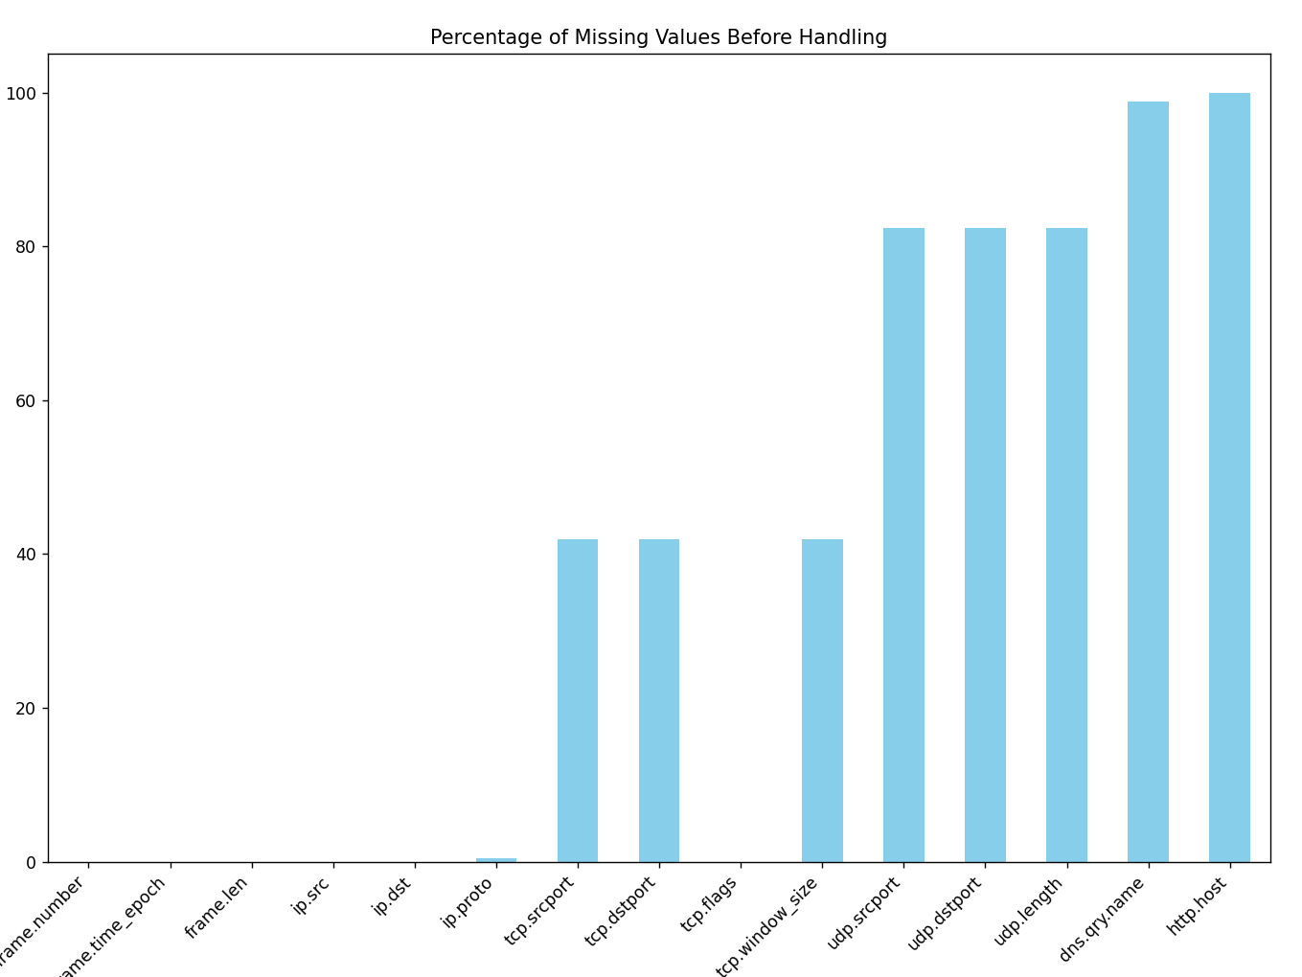

- Traffic Distribution
# Traffic Distribution
plt.figure(figsize=(8, 6))
protocol_counts = df['ip.proto'].value_counts().rename({6: 'TCP', 17: 'UDP', 1: 'ICMP', 50: 'ESP', 103: 'PIM'})
protocol_counts.plot(kind='bar', color='lightblue')
plt.title(f'Protocol Distribution Before Handling - {filename}')
plt.xlabel('Protocol')
plt.ylabel('Packet Count')
plt.xticks(rotation=0)
plt.show()

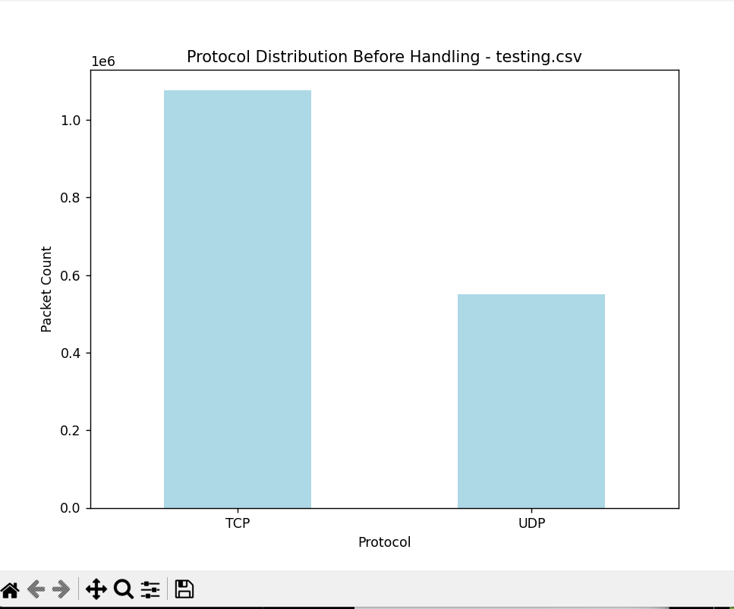

Handling
- Handling

Filling Missing and dropping dns.qry and http.host
import pandas as pd
import os

input_folder = r"C:\Users\Skeletron\Desktop\dataset"

for filename in os.listdir(input_folder):
if filename.endswith(".csv"):
file_path = os.path.join(input_folder, filename)
print(f"Processing file: {filename}")

df = pd.read_csv(file_path, low_memory=False)

# Fillign missing values
df['tcp.window_size'] = df['tcp.window_size'].fillna(0)
df['tcp.flags'] = df['tcp.flags'].fillna(0)
df['tcp.srcport'] = df['tcp.srcport'].fillna(0)
df['tcp.dstport'] = df['tcp.dstport'].fillna(0)
df['udp.srcport'] = df['udp.srcport'].fillna(0)
df['udp.dstport'] = df['udp.dstport'].fillna(0)
df['udp.length'] = df['udp.length'].fillna(0)
df['ip.proto'] = df['ip.proto'].fillna(0)

# Dropping dns.qry.name and http.host due to high missing values
df.drop(columns=['dns.qry.name', 'http.host'], inplace=True)

df.to_csv(file_path, index=False)
print(f"Data handling complete for {filename} and saved.")

print("All CSVs handled successfully.")

Data Visualization(After)
- Data Visualization(After)

- Missing Values
# Plot missing values percentage
missing_percent = df.isnull().mean() * 100
plt.figure(figsize=(12, 6))
missing_percent.plot(kind='bar', color='skyblue')
plt.title(f'Percentage of Missing Values After Handling - {filename}')
plt.xlabel('Columns')
plt.ylabel('Percentage Missing (%)')
plt.xticks(rotation=45, ha="right")
plt.show()

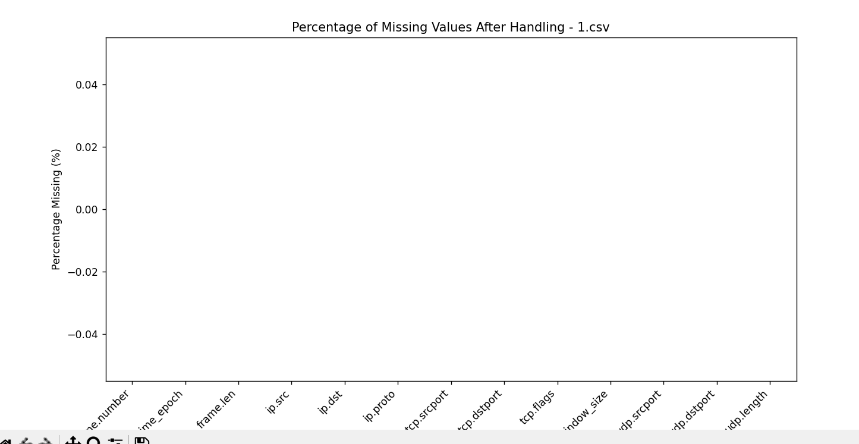

- TCP flag distribution
# TCP/UDP Flag Distribution
plt.figure(figsize=(8, 6))
tcp_flag_counts = df['tcp.flags'].value_counts().sort_index()
tcp_flag_counts.plot(kind='bar', color='lightcoral')
plt.title('Distribution of TCP Flags After Handling - testing.csv')
plt.xlabel('TCP Flag Values')
plt.ylabel('Count')
plt.xticks(rotation=0)
plt.show()

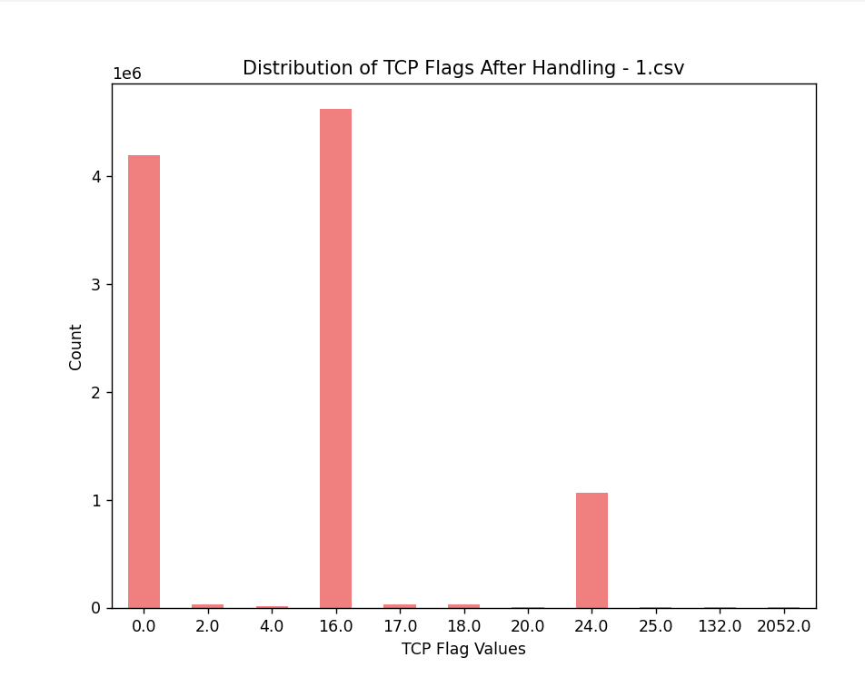
- Traffic Distribution
# Protocol Distribution Check
plt.figure(figsize=(8, 6))
protocol_counts = df['ip.proto'].value_counts().rename({6: 'TCP', 17: 'UDP', 1: 'ICMP', 50: 'ESP', 103: 'PIM'})
protocol_counts.plot(kind='bar', color='lightblue')
plt.title('Protocol Distribution After Handling - testing.csv')
plt.xlabel('Protocol')
plt.ylabel('Packet Count')
plt.xticks(rotation=0)
plt.show()

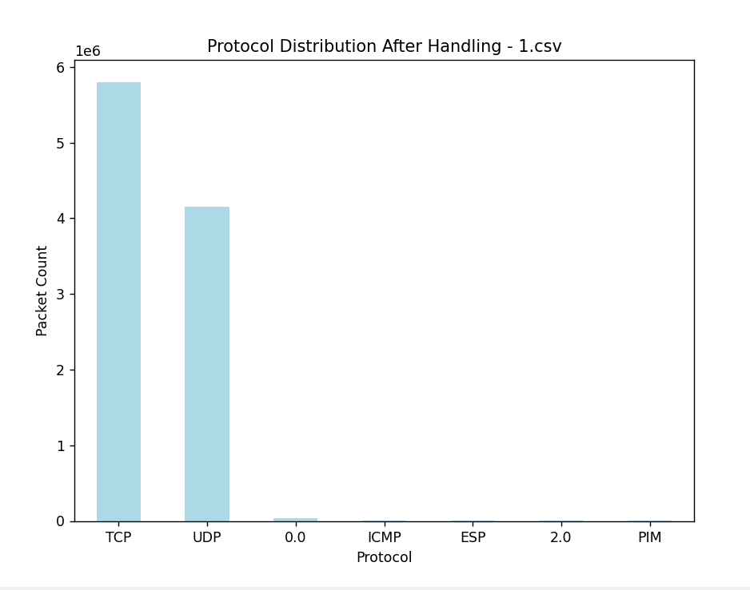

- Top 10 ips (src)
- plt.figure(figsize=(10, 5))
- df['ip.src'].value_counts().head(10).plot(kind='bar', color='lightgreen')
- plt.title('Top 10 Source IPs After Handling - testing.csv')
- plt.xlabel('Source IP')
- plt.ylabel('Count')
- plt.xticks(rotation=45, ha="right")
- plt.show()

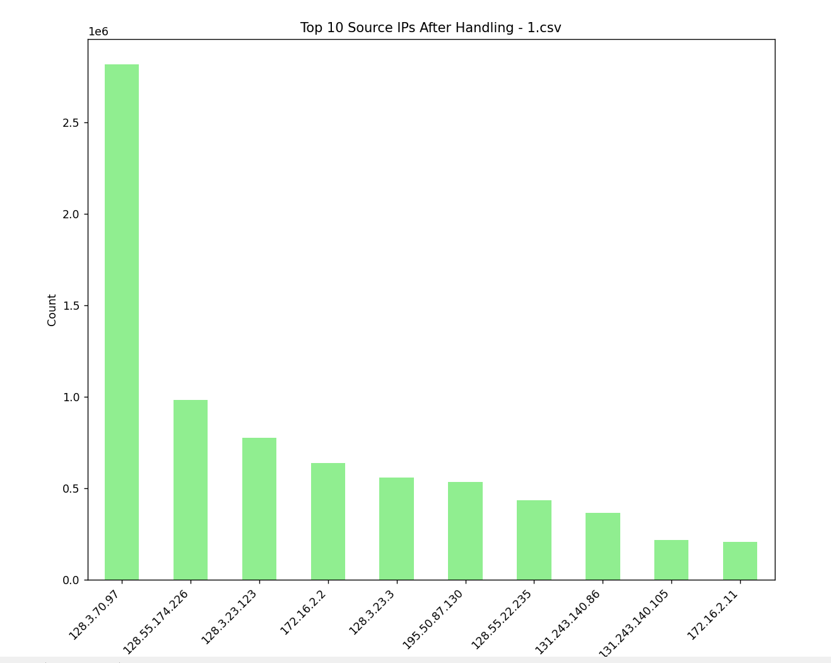

5) Top 10 ips (dst)

plt.figure(figsize=(10, 5))
df['ip.dst'].value_counts().head(10).plot(kind='bar', color='lightblue')
plt.title('Top 10 Destination IPs After Handling - testing.csv')
plt.xlabel('Destination IP')
plt.ylabel('Count')
plt.xticks(rotation=45, ha="right")
plt.show()
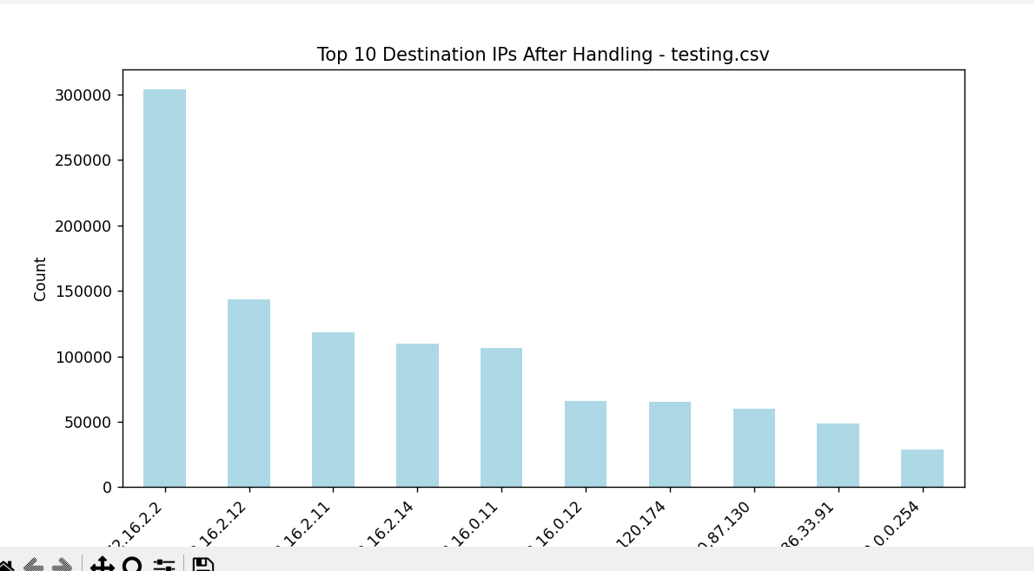

6) Malicious V/s Non Malicious Network
#Malicious vs Non-Malicious
plt.figure(figsize=(8, 5))
counts = df['is_malicious'].value_counts()
counts.index = counts.index.map({0: 'Non-Malicious', 1: 'Malicious'})
counts.plot(kind='bar', color=['green', 'red'], alpha=0.7)
plt.title('Malicious vs Non-Malicious Traffic Count')
plt.xlabel('Traffic Type')
plt.ylabel('Number of Flows')
plt.xticks(rotation=0)

# Add exact counts on bars
for i, v in enumerate(counts):
plt.text(i, v, str(v), ha='center', va='bottom')

plt.show()
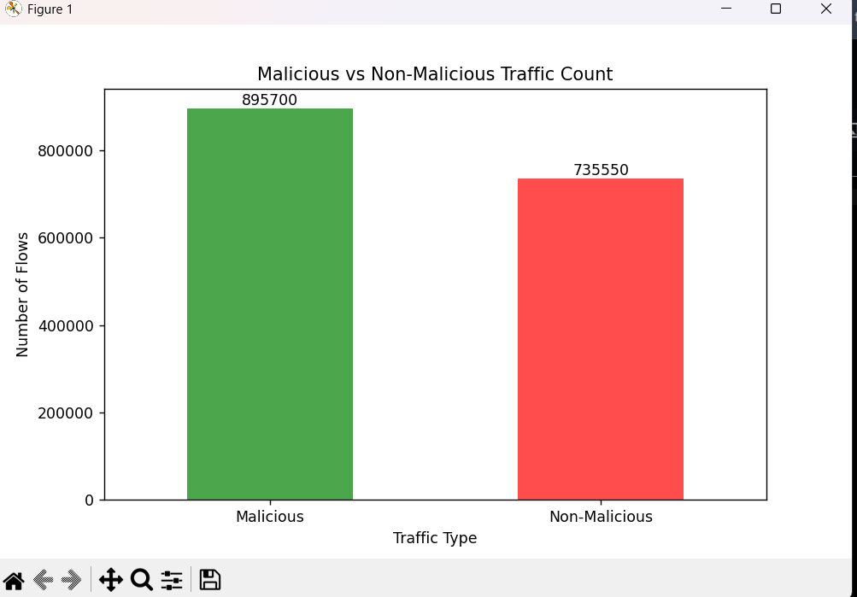

7)Correlation Table
plt.figure(figsize=(10, 8))
numeric_df = df.select_dtypes(include=['float64', 'int64'])
corr = numeric_df.corr()
sns.heatmap(corr, annot=True, fmt='.2f', cmap='coolwarm')
plt.title('Correlation Heatmap - 1.csv')
plt.tight_layout()
plt.show()

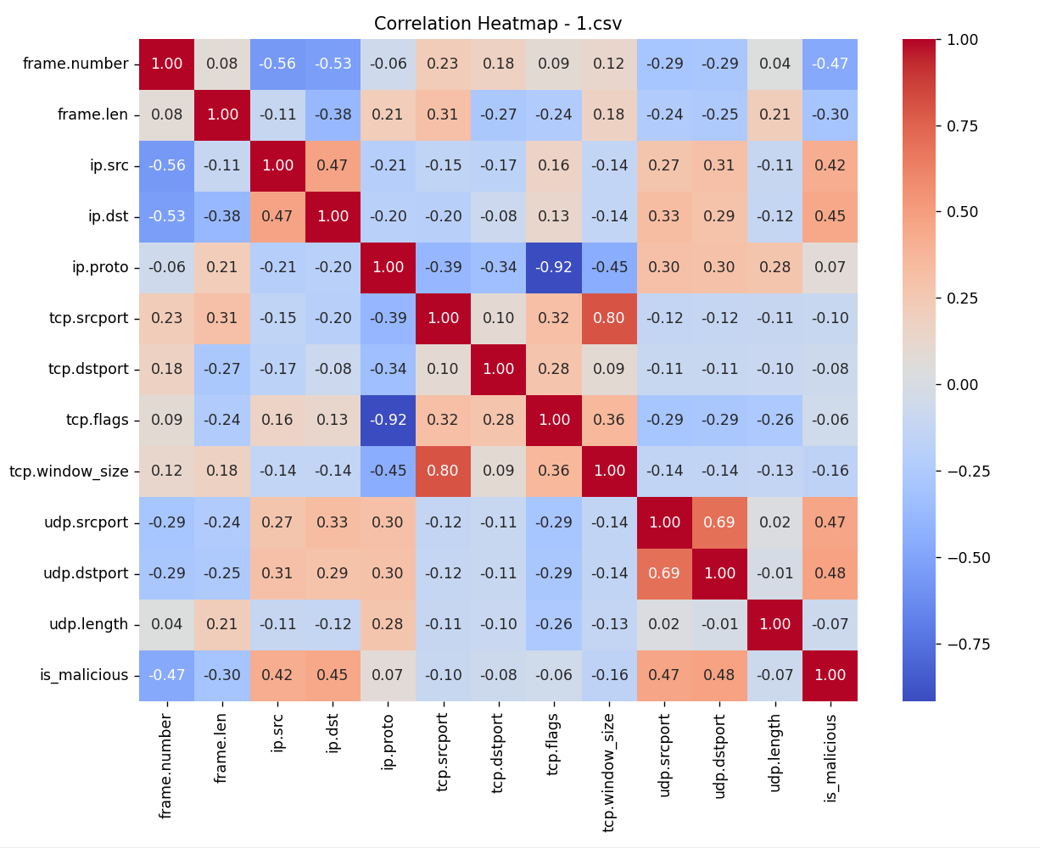

8)Frame Length Distribution
# Frame Length Distribution
plt.figure(figsize=(8, 6))
sns.histplot(df['frame.len'].dropna(), bins=50, kde=True, color='orange')
plt.title('Frame Length Distribution After Handling - testing.csv')
plt.xlabel('Frame Length')
plt.ylabel('Frequency')
plt.show()

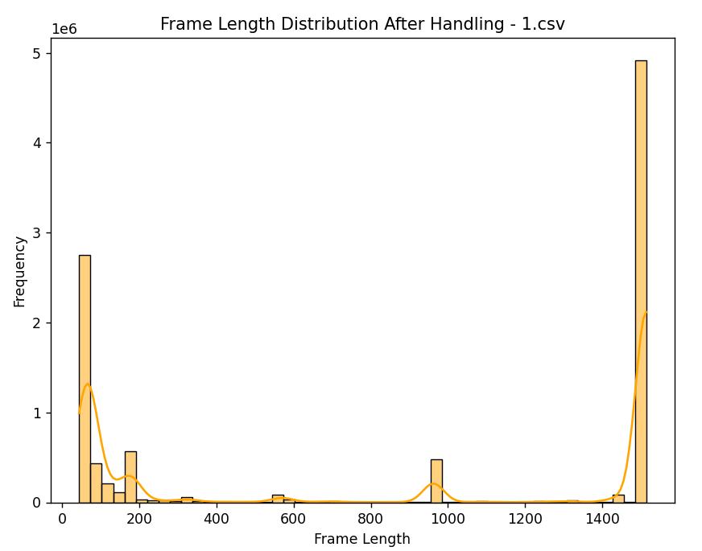

Std/Normalization and Outliers
Std/Normalization and Outliers

Std/Normalization

- Most of our features (e.g., tcp.srcport, ip.proto, tcp.flags) are categorical or identifiers, not continuous.

- Tree-based models (like Random Tree, Decision Tree) which will be used in this project does not require scaling for performance.

Outlier Handing
- In cybersecurity/traffic analysis, outliers (e.g., extremely large frame.len or port anomalies) may indicate malicious activity.
- Removing these would reduce model effectiveness and suppress important threat indicators.
- In real-world traffic, such "irregular" values are expected and meaningful. Preserving them keeps the dataset true to the real environment
- Again Tree-Based Model are not affected by outliers.

Encoding
- Encoding

Ips are very crucial but in the current state cannot be processed. So, using label encoding to map unique ips to a int value

import pandas as pd
from sklearn.preprocessing import LabelEncoder
import joblib
import os

input_folder = r"C:\Users\Skeletron\Desktop\dataset"

# Initialize LabelEncoders for ip.src and ip.dst
src_encoder = LabelEncoder()
dst_encoder = LabelEncoder()

# Collecting unique IPs from all CSVs
all_src_ips, all_dst_ips = set(), set()

# Scan through all CSVs to gather unique IPs
for filename in os.listdir(input_folder):
if filename.endswith(".csv"):
file_path = os.path.join(input_folder, filename)
df = pd.read_csv(file_path, low_memory=False)

# Add unique IPs to the sets
all_src_ips.update(df['ip.src'].dropna().unique())
all_dst_ips.update(df['ip.dst'].dropna().unique())

# Fit the encoders on the combined unique IPs
src_encoder.fit(list(all_src_ips))
dst_encoder.fit(list(all_dst_ips))

# Save the encoders for future use
joblib.dump(src_encoder, os.path.join(input_folder, 'ip_src_encoder.pkl'))
joblib.dump(dst_encoder, os.path.join(input_folder, 'ip_dst_encoder.pkl'))

print("Encoders trained and saved successfully.")

# Encode IPs in each CSV
for filename in os.listdir(input_folder):
if filename.endswith(".csv"):
file_path = os.path.join(input_folder, filename)
df = pd.read_csv(file_path, low_memory=False)

# Apply Label Encoding
df['ip.src'] = src_encoder.transform(df['ip.src'].fillna('<empty>'))
df['ip.dst'] = dst_encoder.transform(df['ip.dst'].fillna('<empty>'))

# Save the encoded data (overwrite the original)
df.to_csv(file_path, index=False)
print(f"{filename} encoded successfully.")

print("All CSVs encoded successfully.")

Feature Extraction

Feature Extraction
Raw packet-level data was aggregated into flow-based features to better capture traffic behavior. Each flow was identified using a combination of source/destination IPs, ports, and protocol. The following features were extracted:
- Traffic Stats: Packet count, total bytes, average and standard deviation of packet size.
- Temporal Features: Flow duration, bytes per second, packets per second.
- Behavioral Indicators: TCP flag count and number of small packets (<128 bytes).
- Flow Labeling: A flow was marked malicious if any packet within it was labeled as such.
Port fields were unified across TCP and UDP, and missing values (e.g., in standard deviation) were handled appropriately. These flow-level features allow machine learning models to detect botnet activity more effectively than raw packet data.

CODE:
import os
import pandas as pd
import numpy as np

def process_file(path):
df = pd.read_csv(path)

# Convert timestamp
df['frame.time_epoch'] = pd.to_datetime(
df['frame.time_epoch'],
errors='coerce',
format='mixed'
)

# Unified ports
df['src_port'] = df['tcp.srcport'].replace(0, np.nan).fillna(df['udp.srcport'])
df['dst_port'] = df['tcp.dstport'].replace(0, np.nan).fillna(df['udp.dstport'])

# Flow ID
df['flow_id'] = (
df['ip.src'].astype(str) + "-" +
df['ip.dst'].astype(str) + "-" +
df['ip.proto'].astype(str) + "-" +
df['src_port'].astype(str) + "-" +
df['dst_port'].astype(str)
).apply(hash).astype('int64')

# Aggregation
agg_df = df.groupby('flow_id').agg(
ip_src=('ip.src', 'first'),
ip_dst=('ip.dst', 'first'),
proto=('ip.proto', 'first'),
src_port=('src_port', 'first'),
dst_port=('dst_port', 'first'),
packet_count=('frame.len', 'count'),
total_bytes=('frame.len', 'sum'),
avg_packet_size=('frame.len', 'mean'),
std_packet_size=('frame.len', 'std'),
flow_start=('frame.time_epoch', 'min'),
flow_end=('frame.time_epoch', 'max'),
is_malicious=('is_malicious', 'max'),
tcp_flag_count=('tcp.flags', lambda x: x.notna().sum()),
small_packets=('frame.len', lambda x: (x < 128).sum())
).reset_index()

# Derived features
agg_df['flow_start'] = pd.to_datetime(agg_df['flow_start'], errors='coerce')
agg_df['flow_end'] = pd.to_datetime(agg_df['flow_end'], errors='coerce')
agg_df['flow_duration'] = (agg_df['flow_end'] - agg_df['flow_start']).dt.total_seconds().replace(0, 1e-6)
agg_df['bytes_per_second'] = agg_df['total_bytes'] / agg_df['flow_duration']
agg_df['packets_per_second'] = agg_df['packet_count'] / agg_df['flow_duration']

# Cleanup
agg_df['std_packet_size'] = agg_df['std_packet_size'].fillna(-1)
agg_df.drop(columns=['flow_start', 'flow_end'], inplace=True)

# Round
round_cols = ['avg_packet_size', 'std_packet_size', 'flow_duration', 'bytes_per_second', 'packets_per_second']
agg_df[round_cols] = agg_df[round_cols].round(6)

# Order columns
column_order = [
'flow_id', 'ip_src', 'ip_dst', 'proto', 'src_port', 'dst_port',
'packet_count', 'total_bytes', 'avg_packet_size', 'std_packet_size', 'small_packets',
'flow_duration', 'bytes_per_second', 'packets_per_second', 'tcp_flag_count', 'is_malicious'
]
agg_df = agg_df[column_order]

# Save
agg_df.to_csv(path, index=False)
print(f"Processed: {os.path.basename(path)}")

# Batch run on all 17 CSVs
base_path = r"C:\Users\Skeletron\Desktop\dataset"
for i in range(1, 18):
file_path = os.path.join(base_path, f"{i}.csv")
process_file(file_path)

Visualisation
Visualisation

Violin Plot:
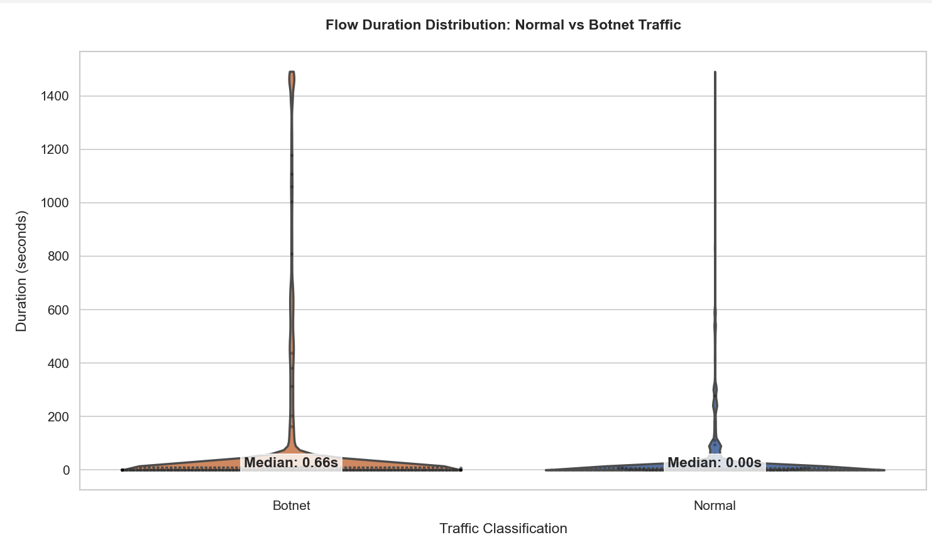
Description:
This violin plot visualizes how long individual flows last in botnet vs normal traffic. The quartiles and swarm points highlight density and variance, while median annotations make the comparison clearer.
Insight:
Botnet traffic often has distinct flow duration patterns, helping distinguish it from normal activity.

Traffic Timeline:
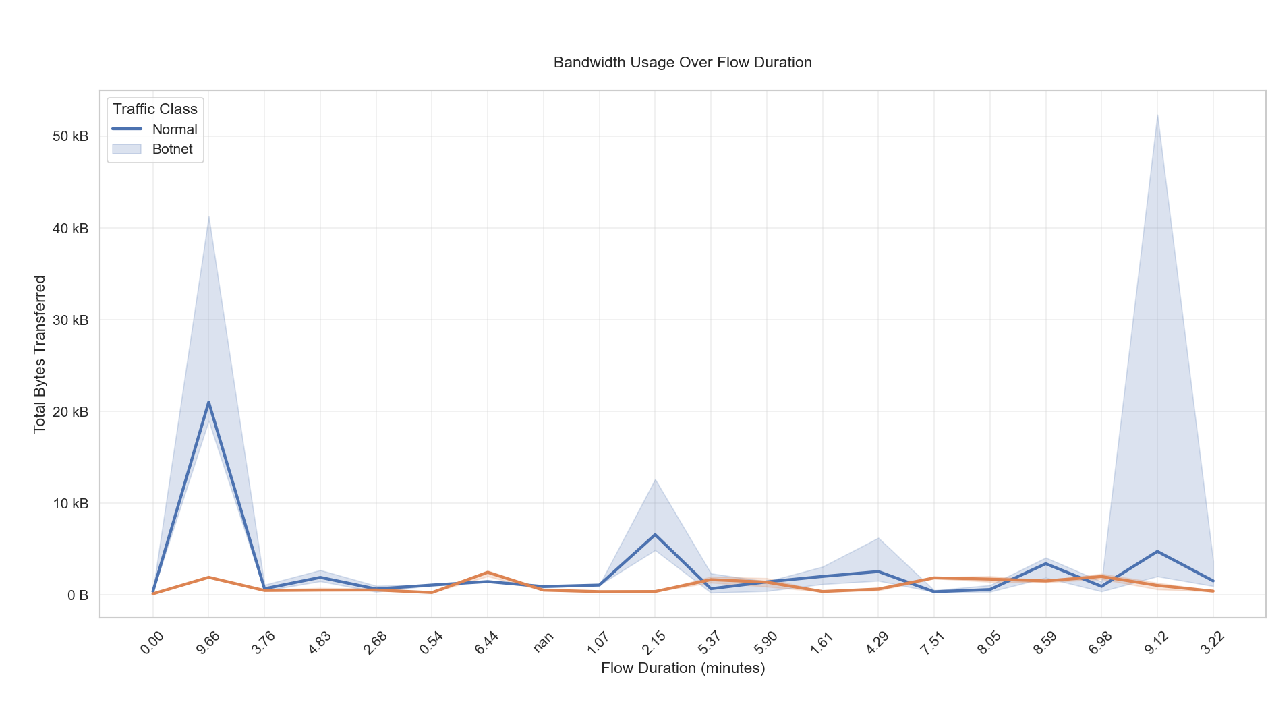
Description:
Line plot showing the median bytes transferred across different flow duration bins (in minutes), split by traffic type. Error bars show 95% confidence intervals.
Insight:
Reveals how bandwidth usage patterns change over time and differ between normal and malicious traffic.

Port Activity Heatmap
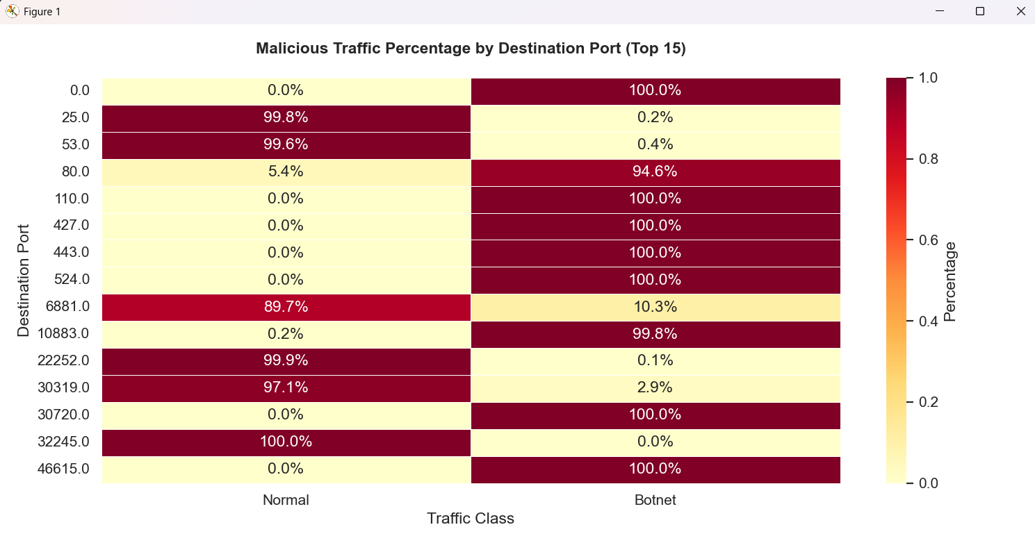
Description:
A heatmap showing the percentage of malicious vs normal flows for the top 15 most used destination ports.
Insight:
Identifies which ports are more prone to botnet traffic, useful for setting network monitoring priorities.

Packet Size Distribution:
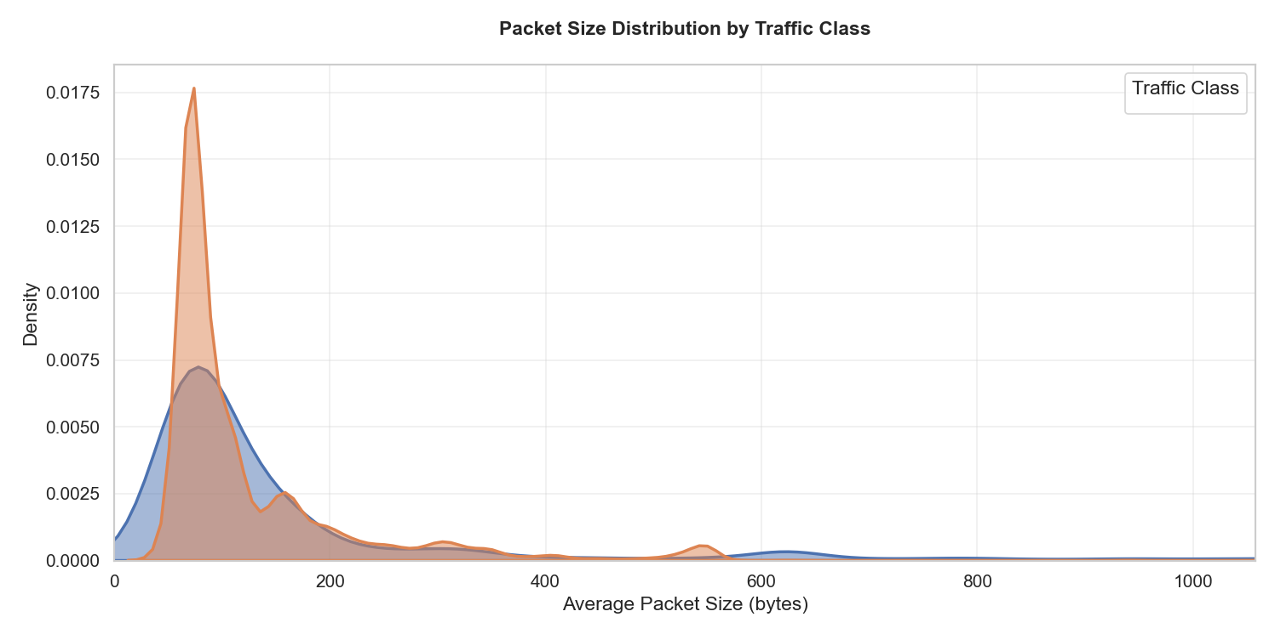
Description:
Kernel Density Estimation (KDE) plot for average packet sizes in each traffic class, showing how packet sizes vary and overlap.
Insight:
Malicious traffic favor certain packet sizes, aiding in behavior-based detection techniques.

Testing Models
Testing Models

DecisionTreeClassifier

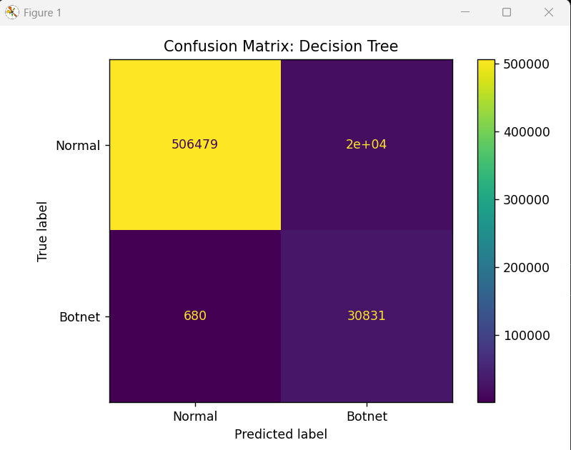
precision recall f1-score support

Normal 1.00 0.96 0.98 525999
Botnet 0.61 0.98 0.75 31511

accuracy 0.96 557510
macro avg 0.81 0.97 0.87 557510
weighted avg 0.98 0.96 0.97 557510

RandomForestClassification

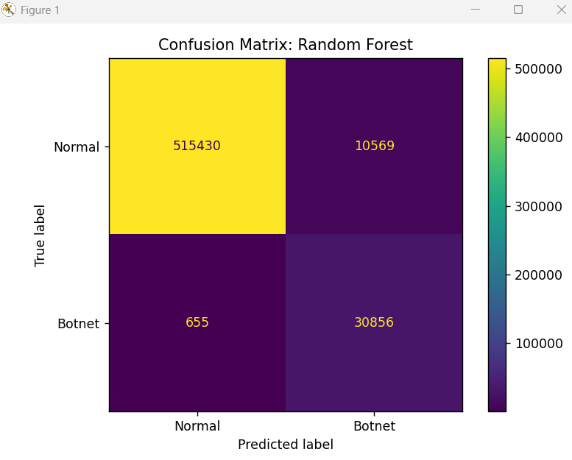

Training Random Forest...
precision recall f1-score support

Normal 1.00 0.98 0.99 525999
Botnet 0.74 0.98 0.85 31511

accuracy 0.98 557510
macro avg 0.87 0.98 0.92 557510
weighted avg 0.98 0.98 0.98 557510

ExtraTreesClassification
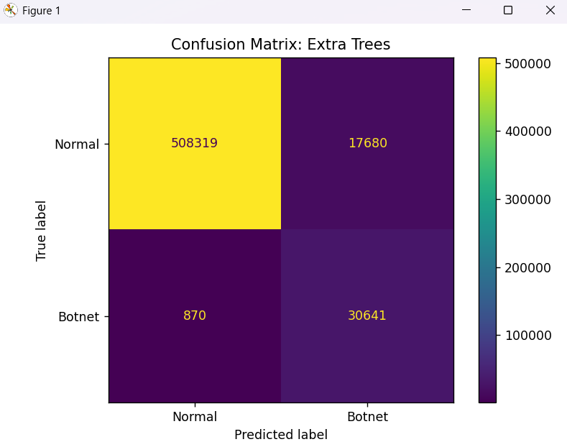
Training Extra Trees...
precision recall f1-score support

Normal 1.00 0.97 0.98 525999
Botnet 0.63 0.97 0.77 31511

accuracy 0.97 557510
macro avg 0.82 0.97 0.87 557510
weighted avg 0.98 0.97 0.97 557510

Comparing Model Results
Comparing Model Results

Decision_Tree v/s Random Forest v/s Extra Trees
- Metrics Comparison

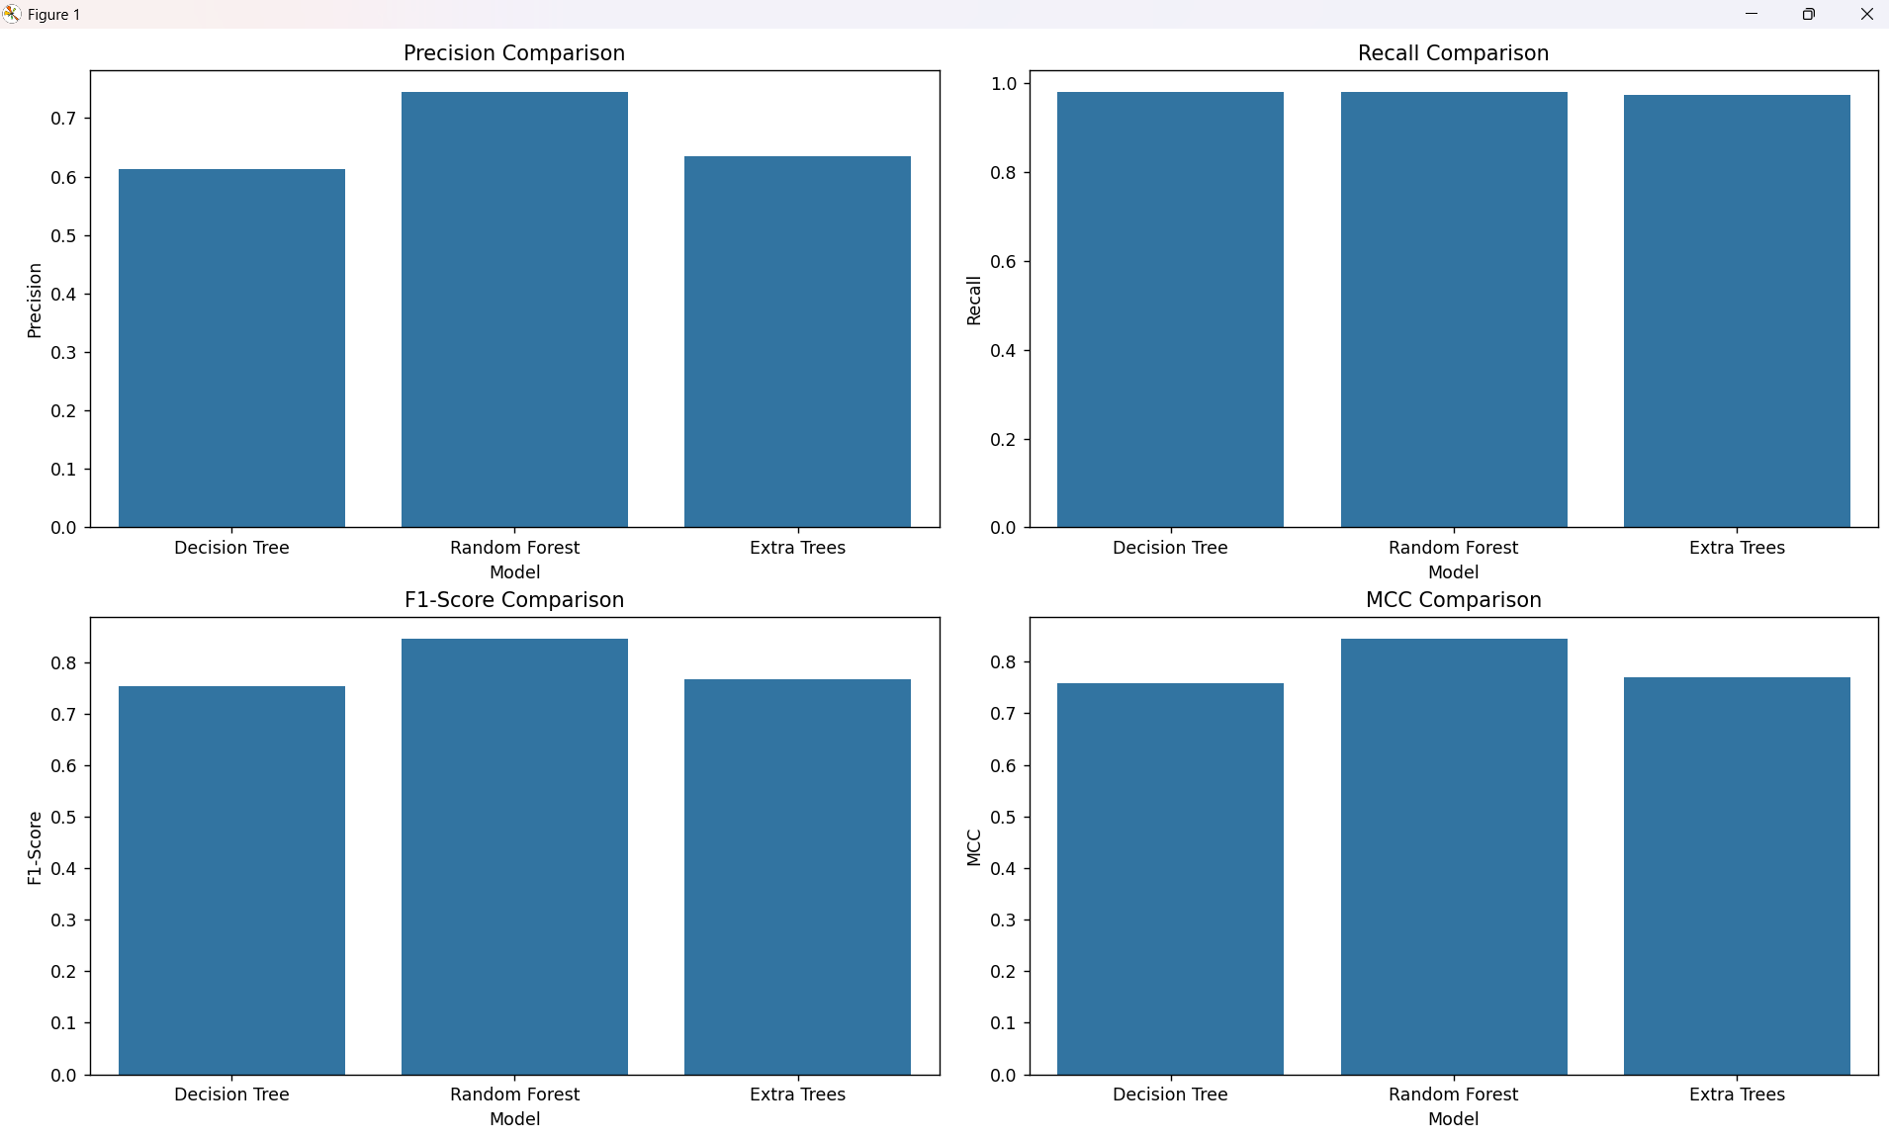

- Training Time
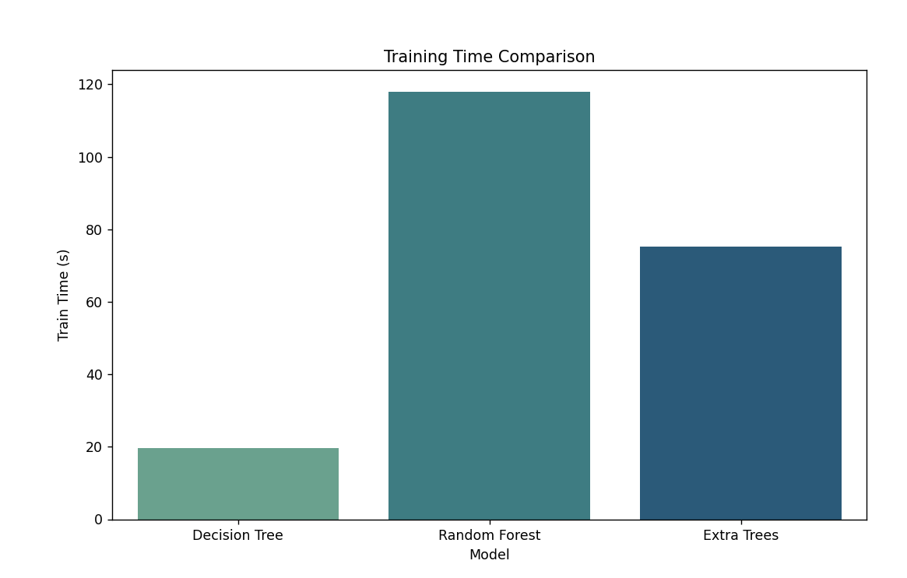
- Testing Time
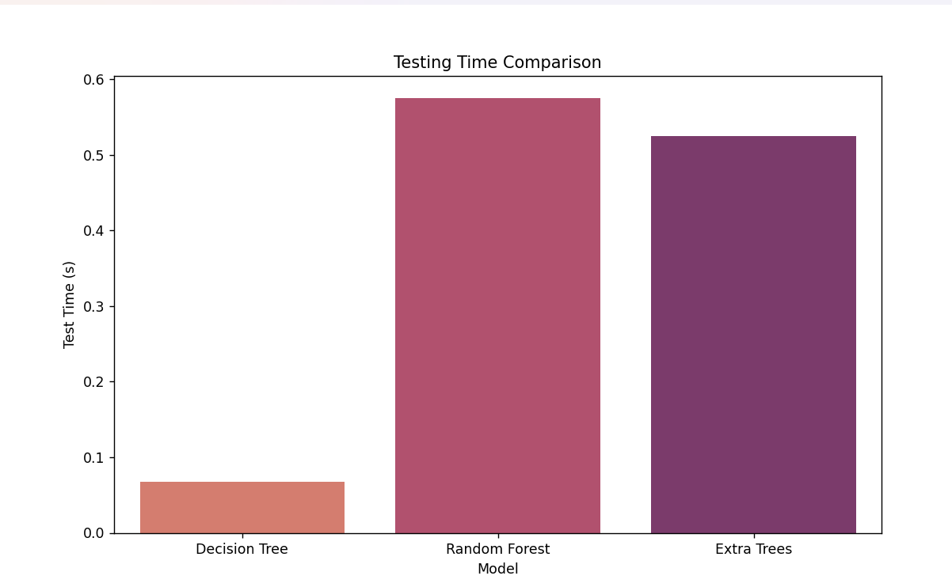

Fine Tuning
Fine Tuning

Training Random Forest models at varying depths...
Depth 1: Train F1 = 0.7469, Test F1 = 0.2147
Depth 3: Train F1 = 0.9200, Test F1 = 0.5539
Depth 5: Train F1 = 0.9517, Test F1 = 0.6083
Depth 7: Train F1 = 0.9615, Test F1 = 0.6679
Depth 9: Train F1 = 0.9725, Test F1 = 0.7383
Depth 11: Train F1 = 0.9749, Test F1 = 0.7507
Depth 13: Train F1 = 0.9807, Test F1 = 0.7978
Depth 15: Train F1 = 0.9840, Test F1 = 0.8170
Depth 17: Train F1 = 0.9865, Test F1 = 0.8252
Depth 19: Train F1 = 0.9890, Test F1 = 0.8270
Depth 21: Train F1 = 0.9910, Test F1 = 0.8265
Depth 23: Train F1 = 0.9933, Test F1 = 0.8300
Depth 25: Train F1 = 0.9951, Test F1 = 0.8341
Depth 27: Train F1 = 0.9963, Test F1 = 0.8365
Depth 29: Train F1 = 0.9970, Test F1 = 0.8389

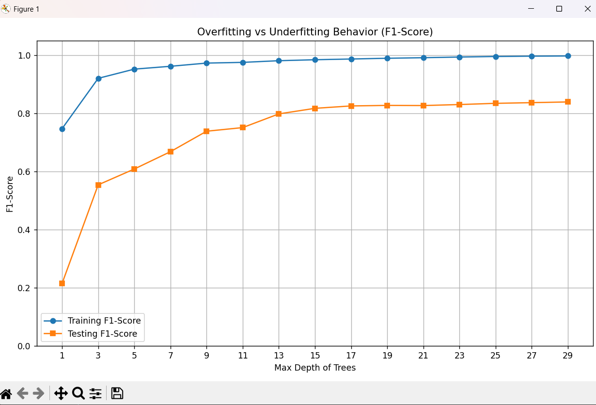

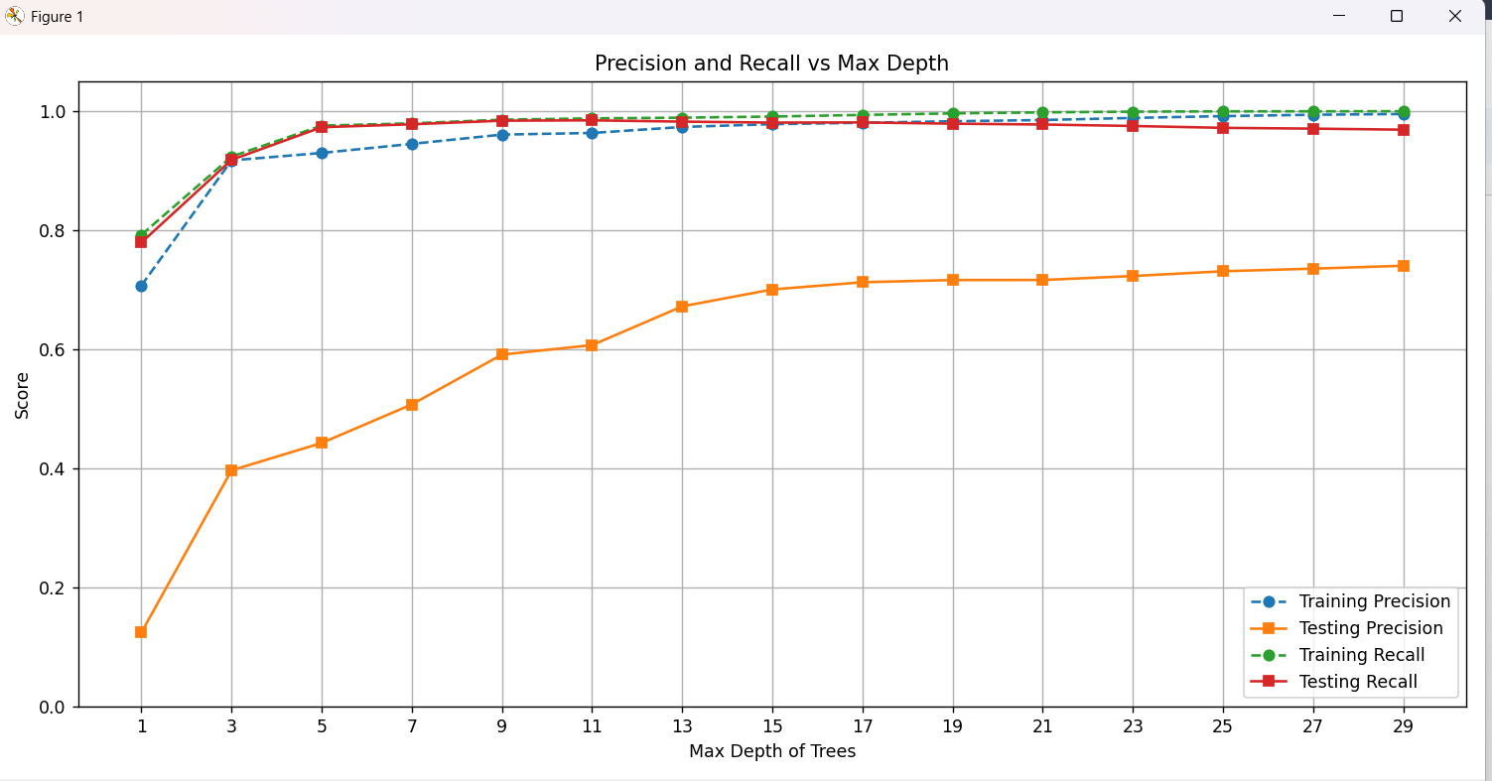

ROC Curve
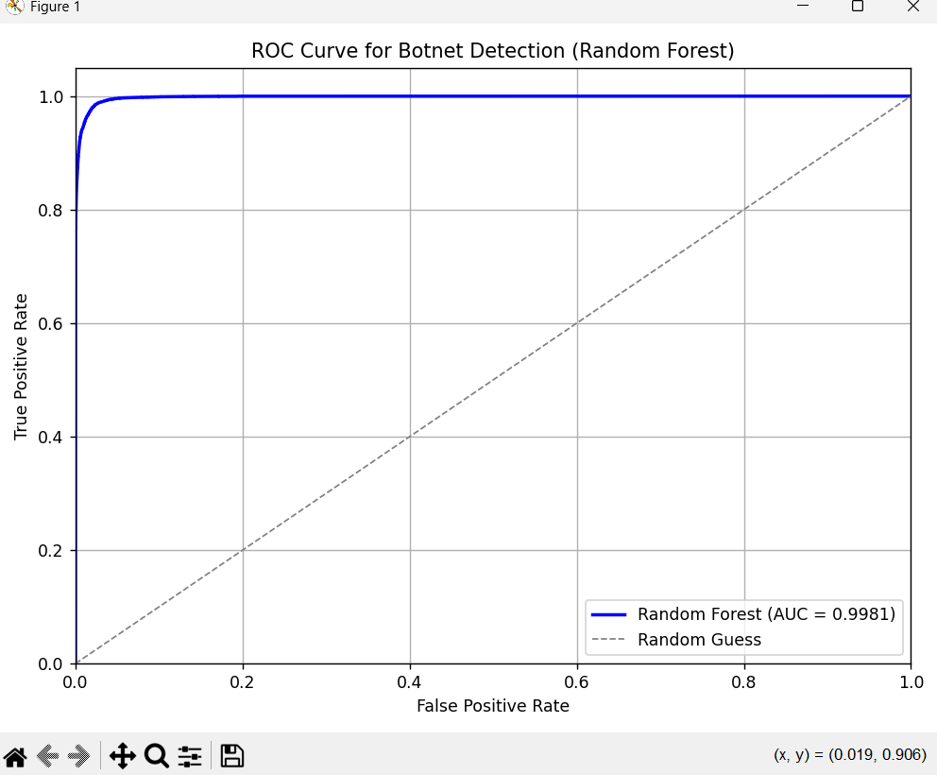
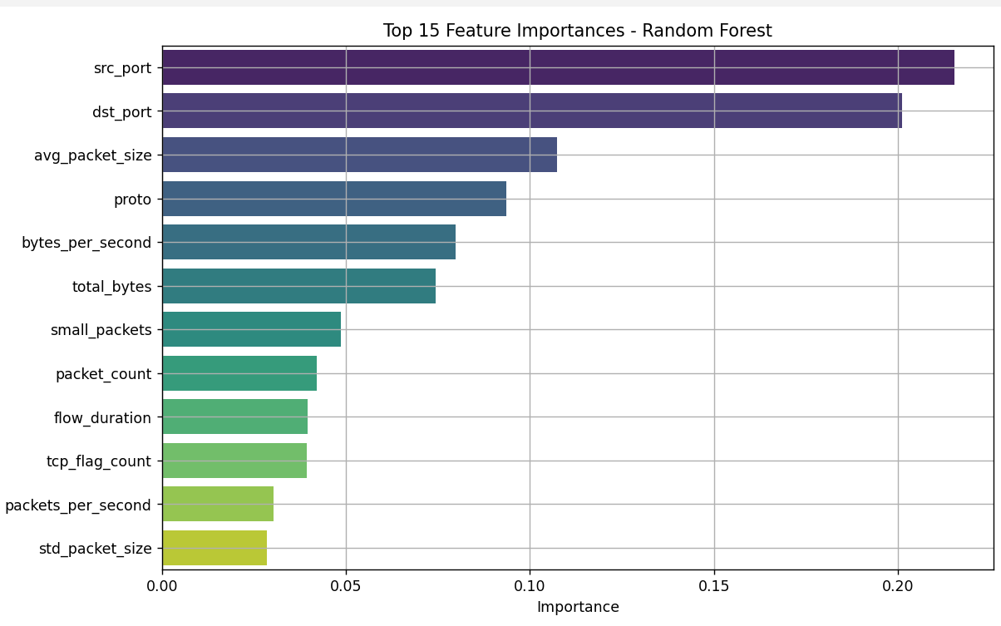

Classification Report:
precision recall f1-score support

Normal 1.00 0.98 0.99 525999
Botnet 0.74 0.98 0.85 31511

accuracy 0.98 557510
macro avg 0.87 0.98 0.92 557510
weighted avg 0.98 0.98 0.98 557510

